Control Engineering II

Handout – Online Laboratory 4

Name: *Colda Andreea Ariana*

Group: *30332*

**1:** For the process described by the transfer function:

,

Determine the discrete-time controller usign Kalman tuning method and a sampling period of Ts=1 sec.

3.8647 – 2.8649z^(-1)

Hr = -----------------------------------------

1 – 0.1586z^(-2) + 0.8413z^(-3)

Evaluate the closed loop performance in Simulink.

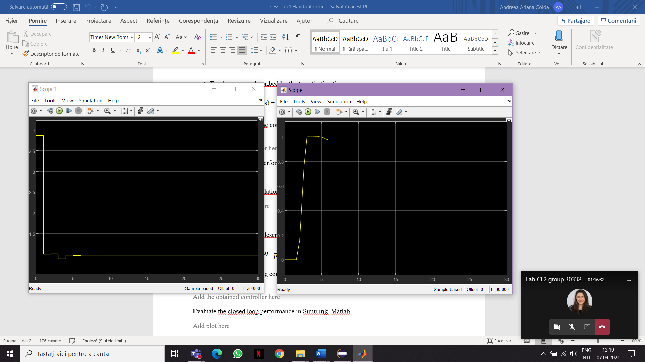



The control signal

Compute the recurrence relation for the control signal.

**2:** For the process described by the transfer function:

,

Determine the discrete-time controller usign Dahlin’s tuning method and a sampling period of TE=1 sec.

134.54 (z-0.9814) (z-0.7156)

Hr = -------------------------------------------

(z-1) (z+0.8889) (z^2 + 0.07997z + 0.07996)

I had some problems with this one.

Evaluate the closed loop performance in Simulink, Matlab.

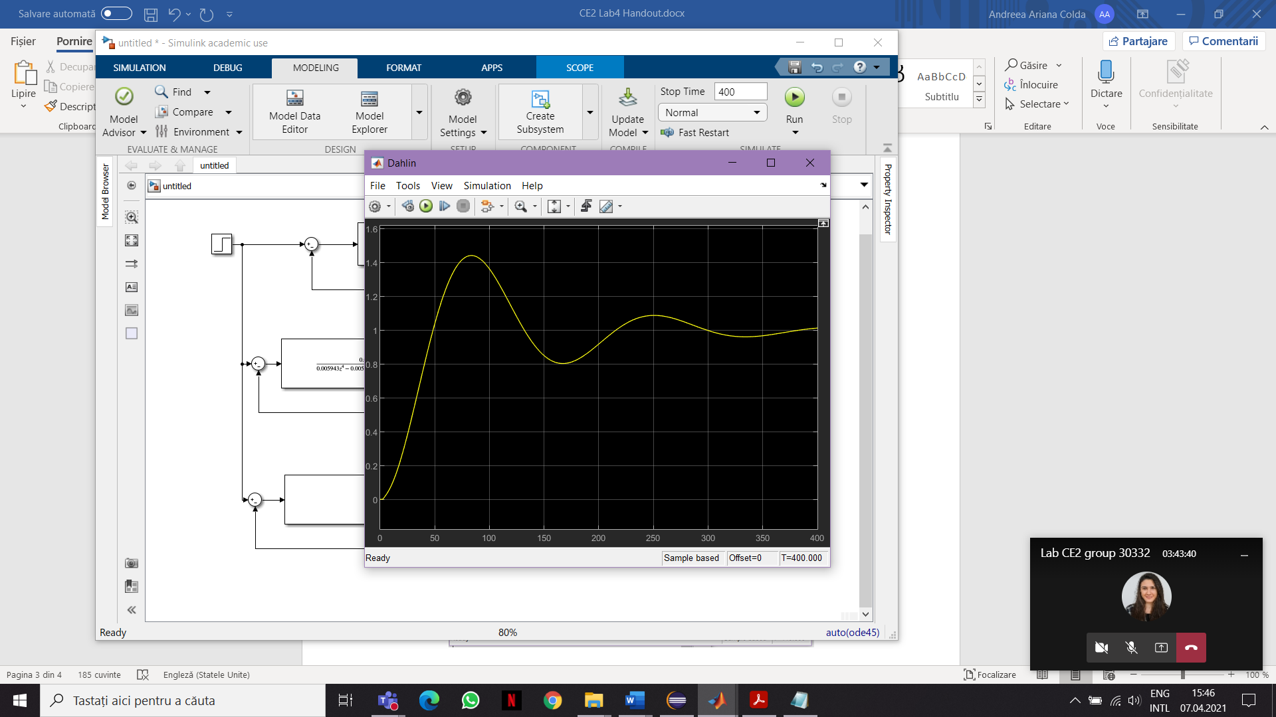

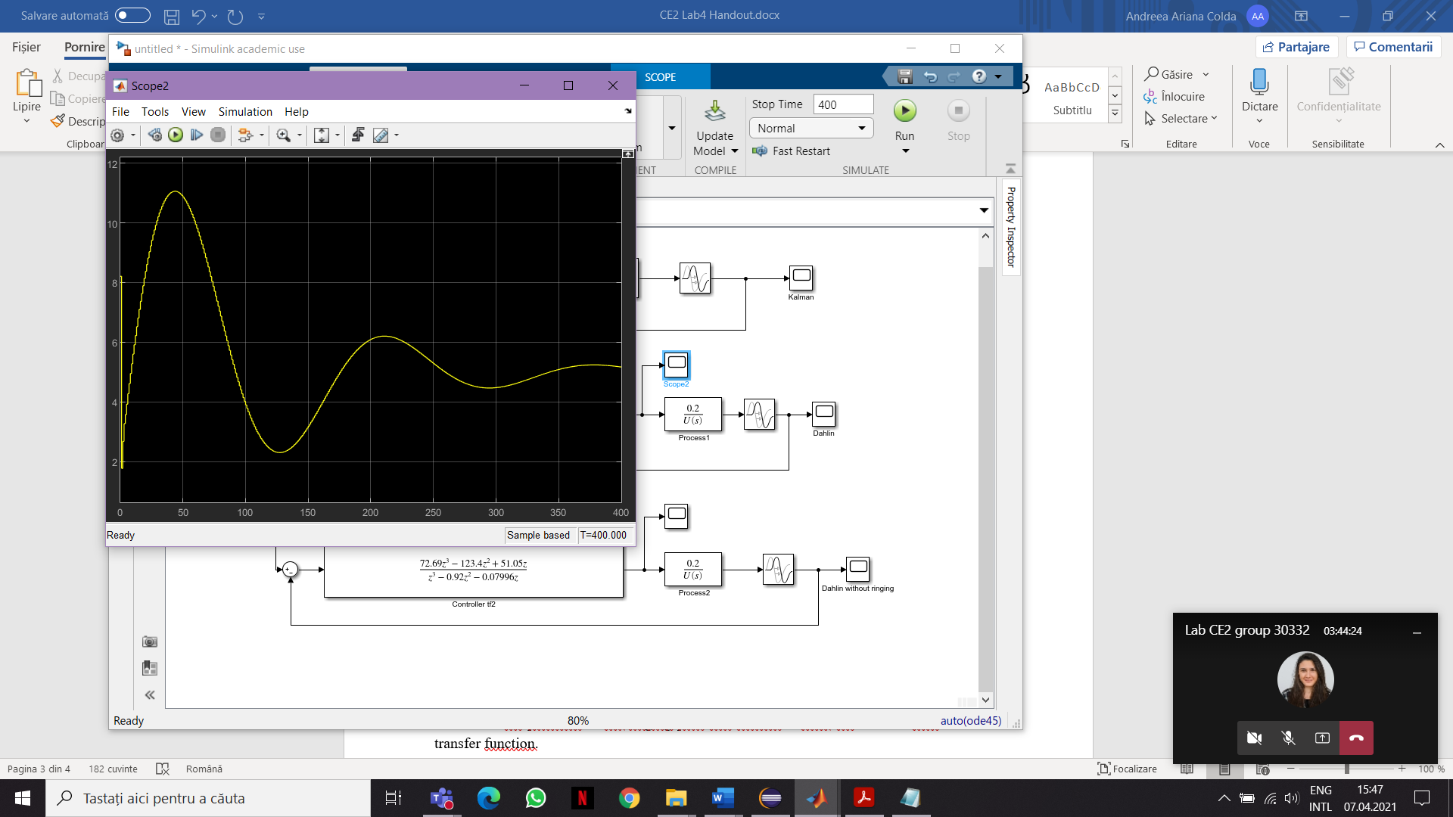

The control signal

Determine the presence of the ringing pole and remove it from the discrete-time controller transfer function.

Ringing pole: (z+0.8889) because is real and negative and it is the closest to the unit circle.

Using the modified discrete-time controller, evaluate the closed loop performance using Simulink, Matlab and compare the results with the original ones.

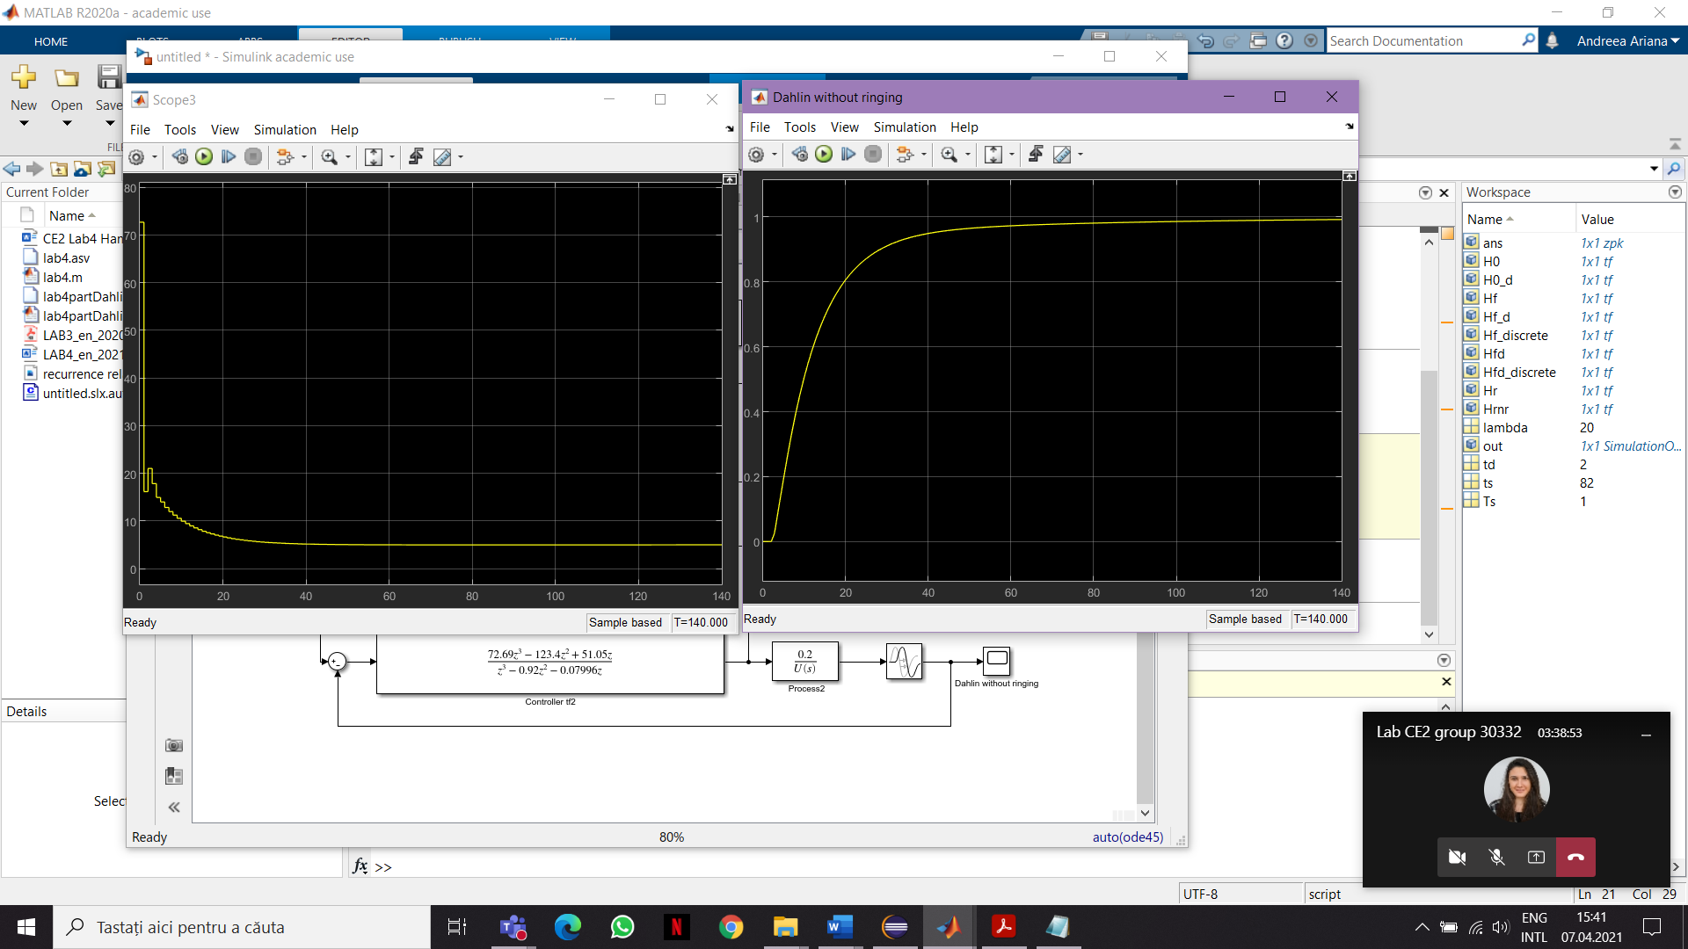



Compute the recurrence relation for the control signal (using the modified discrete-time controller)

u(k) = 0.92u(k-1) + 0.07996u(k-2) + 72.69e(k) - 123.4e(k-1) + 51.05e(k-2)